OPTIMIZING TELECOM OPERATIONS WITH SEGMENTATION AND CHURN PREDICTION

Dandu Neha
B.Tech. Student, Dept. of CSE
Institute of Aeronautical Engineering
Hyderabad, India
21951A05B8@iare.ac.in
K.Sangeeta
Assisstant Professor of CSE
Institute of Aeronautical Engineering
Hyderabad, India
K.sangeeta.iare.ac.in
Mohammed Ameesha
B.Tech. Student, Dept. of CSE
Institute of Aeronautical Engineering
Hyderabad, India
21951A05A4@iare.ac.in
line 5: email address or ORCID
Mukka Dheeraj
B.Tech. Student, Dept. of CSE
Institute of Aeronautical Engineering
Hyderabad, India
21951A0538@iare.ac.in

Abstract— Client turnover is a significant issue and one of the top concerns for large businesses, particularly in the telecom sector, due to its direct impact on company profits. Companies are striving to develop methods to forecast probable outcomes to mitigate this impact. Identifying the factors contributing to customer churn is crucial for preventing it. Our work's key contribution is the creation of a churn prediction model that aids telecom providers in identifying customers who are most likely to churn. We analyze various scenarios of data analysis and present the results in graphical format. The model developed employs machine learning methods in a large data environment and introduces a novel approach for designing and selecting features. The datasets used to train, evaluate, and assess the algorithm include all customer data from previous months. We tested four different algorithms: Logistic Regression, Extreme Gradient Boosting (XGBoost), Gradient Boosted Machine (GBM) Trees, Random Forests, and Decision Trees. To increase the model's accuracy, the algorithms are trained with parameter tuning. This work focuses on optimizing telecom operations with segmentation and churn prediction, ultimately enhancing operational efficiency and customer retention.
Keywords— Customer churn, churn prediction, telecom operations, machine learning, feature selection, customer segmentation, operational efficiency.

Introduction
In the highly competitive telecommunication industry, customer churn—when customers discontinue their service subscriptions—poses a significant challenge. The cost of acquiring new customers often surpasses the expenses associated with retaining existing ones, making churn reduction a critical focus for telecom operators. High churn rates can erode profitability and market share, underscoring the need for effective churn prediction and management strategies. Machine learning (ML) offers a transformative approach to address this challenge. By leveraging vast amounts of historical customer data, including service usage patterns, demographic details, and interaction histories, ML models can predict the likelihood of a customer discontinuing their service. This predictive capability allows telecom companies to proactively engage with customers who are at risk of churning, offering personalized incentives or improving service quality to retain them. The development of a churn prediction model involves several key steps: data collection and preprocessing, feature selection and engineering, model training, and evaluation. Data from various sources such as call records, billing information, customer service interactions, and social media can be integrated to form a comprehensive view of each customer's behavior. Advanced ML algorithms, including logistic regression, decision trees, random forests, and neural networks, can be employed to analyze these data points and identify patterns indicative of churn. Effective churn prediction not only helps in retaining customers but also provides insights into the underlying reasons for churn. These insights can drive strategic decisions in product development, customer service enhancements, and targeted marketing campaigns. Moreover, reducing churn rates translates directly into increased customer lifetime value and a more stable revenue base. The project aims to build a scalable and accurate churn prediction system that can be seamlessly integrated into a telecom operator's existing infrastructure. By doing so, telecom companies can move from reactive to proactive customer relationship management, enhancing customer satisfaction and loyalty in a fiercely competitive market.

Literature Survey
The telecommunications sector has made significant strides in developing customer retention strategies, particularly through predictive models aimed at reducing customer churn. Understanding customer behavior, loyalty, and satisfaction is vital for improving retention initiatives, as highlighted by Gerpott et al. (2001) in their study of the German market [1].

Various approaches have been explored for predicting churn, including data mining techniques that transform call details into valuable insights, as demonstrated by Wei and Chiu (2002) [2]. Machine learning models have also been extensively applied to forecast churn, with Qureshi et al. (2013) presenting a model specifically designed for the telecommunications industry [3].

The challenges of preemptive churn prevention are discussed by Ascarza et al. (2016), who conducted a field experiment on plan recommendations, revealing the potential downsides of such strategies [4]. In a similar vein, Bott (2014) examined the use of neural networks for churn prediction, focusing on the application of multilayer perceptron models [5].

Umayaparvathi and Iyakutti (2016) conducted a comprehensive survey on the datasets, methods, and metrics used in churn prediction within the telecom industry, highlighting the complexity and diversity of approaches in this field [6]. Yu et al. (2005) developed a model for aligning churn strategies, providing managers with tools to optimize their approaches [7].

Addressing the issue of class imbalance in churn prediction models, Burez and Van den Poel (2009) offered solutions to enhance the accuracy of these models [8]. The identification of influential communities within networks, as explored by Zhan et al. (2016) and Barthelemy (2004), is crucial for understanding customer interactions and churn behavior [9, 10].

Recent research has focused on the application of machine learning techniques in intelligent churn prediction. For example, Idris et al. (2012) demonstrated how these techniques can improve prediction accuracy in the telecom sector [13]. Hwang et al. (2004) and Huang et al. (2012) expanded on this by integrating customer value models and hybrid neural networks into churn prediction models [14, 15].

Further contributions to the field include the work of Coussement and Van den Poel (2008) on support vector machines, Tsai and Lu (2009) on hybrid neural networks, and Keramati and Mirmohammadi (2009) on data mining techniques for improving prediction accuracy [16, 17, 18].

The use of ensemble learning techniques, as discussed by Verbeke et al. (2014) and Vafeiadis et al. (2015), has been recognized for its ability to enhance churn prediction models by combining multiple algorithms [19, 20]. Coussement and De Bock (2013) demonstrated the versatility of these techniques by applying them in the online gambling industry [21].

Innovative approaches to churn prediction, such as evolutionary data mining algorithms and random forest models, have been explored by researchers like Au et al. (2003) and Idris et al. (2012) [22, 23, 24]. Additionally, Kaur et al. (2013) and Lejeune (2001) examined the impact of ensemble learning and data mining on churn management [25].

The literature on customer churn management has evolved considerably, with Hadden et al. (2007) and Ahn et al. (2006) providing comprehensive analyses of current practices and identifying key factors influencing churn in the Korean telecom market .

Methodology

Proposed work
To tackle the pressing issue of client turnover in the telecom industry, our proposed system aims to develop an advanced churn prediction model. This model is designed to help telecom providers proactively identify customers who are most likely to churn, thereby enabling effective retention strategies.

Our approach utilizes sophisticated machine learning techniques within a large data environment to ensure high prediction accuracy and reliability.
The system includes a comprehensive analysis of customer data, incorporating a novel method for feature design and selection. This ensures that the most relevant factors contributing to churn are effectively identified and used. By examining various data scenarios and presenting the results graphically, we provide clear insights into customer behavior and the key drivers of churn.

We train, evaluate, and validate the model using an extensive dataset that includes detailed customer information from the past months. To determine the most effective predictive approach, we test four different algorithms: Random Forest, Logistic Regression, Extreme Gradient Boosting (XGBoost), and Gradient Boosted Machine Trees (GBM). Additionally, we apply parameter tuning to these algorithms during the training process to further enhance the model's accuracy.

The outcome is a sophisticated churn prediction model that significantly improves telecom providers' ability to anticipate and address customer churn. This proactive strategy enables telecom companies to better understand their customers, implement targeted retention measures, and ultimately enhance their profitability.

Flow chart
Run Web App:
Start the web application by launching it on a local server or through a cloud service. This initializes the app and makes it accessible via a web browser.
Login:
Users need to log in with their credentials (username and password) to access the app's features. This step ensures data security and personalized user settings.
Load Model:
Load an existing churn prediction model into the app. The model could be pre-trained using machine learning algorithms such as Logistic Regression, Decision Trees, or Neural Networks. Loading the model allows the app to use it for making predictions without retraining.

Input Telecom Dataset:
Upload the telecom dataset containing customer information. This dataset typically includes features such as customer demographics, account information, service usage, and previous churn status, which are essential for churn prediction.
Load Dataset:
The app reads and processes the uploaded dataset, ensuring that all data points are correctly formatted and ready for analysis. This step often includes checking for any missing values or data inconsistencies.
Set Parameters:
Configure any necessary parameters for the model, such as thresholds for classification, specific columns to include/exclude, or adjustments to the model’s hyperparameters. This step tailors the model’s operation to the specific dataset and business requirements.
Preprocess Data:
Clean and preprocess the data by handling missing values, encoding categorical variables, normalizing numerical features, and splitting the data into training and test sets if needed. This step ensures the dataset is in a format suitable for the model.
Predict Churn:
Use the loaded model to predict which customers are likely to churn based on the input data. The model analyzes the data and returns a probability score or classification indicating whether each customer is at risk of leaving.
Train Model:
If the model requires updating or retraining, the app can train a new model using the provided dataset. This step involves fitting the model to the training data, optimizing weights, and validating performance on test data.
Save Model:
After training or updating the model, save it to ensure that the most recent version is used for future predictions. Saving the model also allows you to deploy the updated version without retraining each time.
Show Prediction:
Display the churn prediction results to the user. This may include detailed reports, individual customer scores, and visualizations like charts or graphs to help interpret the model's output.
Each step ensures that the churn prediction process is efficient, user-friendly, and adaptable to different datasets and requirements, providing valuable insights for telecom operators.

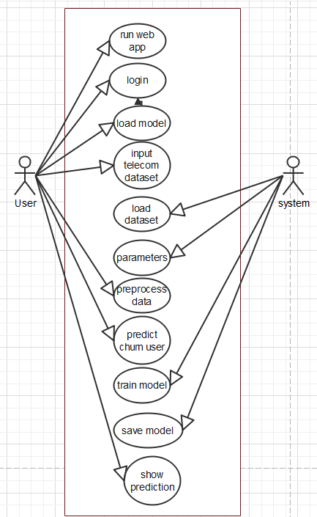

Fig 1. Flow Chart

System Architecture:

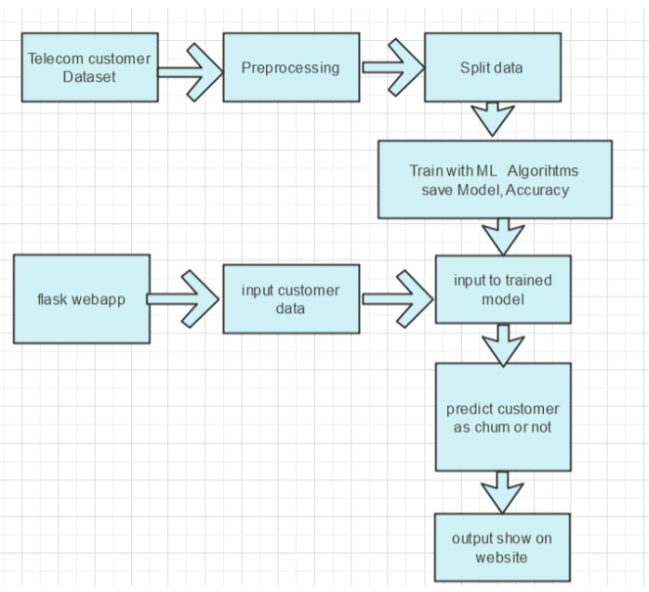

Fig 2. Proposed Architecture

To enhance the effectiveness of telecom operations, a detailed approach was adopted, focusing on accurate churn prediction and operational optimization. The process begins with the collection of a detailed dataset, which encompasses a wide range of customer information such as demographic details, usage patterns, and historical churn data.

The initial phase involves preparing the dataset through data preprocessing. This includes addressing any errors, managing missing values, and normalizing the data to ensure consistency. These steps are essential for ensuring that the data is suitable for analysis and modeling.

Subsequently, the dataset is divided into two parts: one for training and the other for testing. The training portion is utilized to develop and refine the predictive models, while the testing portion is used to assess the performance of these models.

Several advanced machine learning algorithms are employed to create the predictive models. These algorithms include logistic regression, which offers a simple and effective classification method; extreme gradient boosting (XGBoost), which is known for its high accuracy and capability to handle complex data patterns; gradient boosted machine (GBM) trees, which improve prediction performance through boosting techniques; random forests, which provide robustness through ensemble learning; and decision trees, which are valued for their interpretability.

After training the models with the training data, they are evaluated using the testing data to measure their effectiveness and accuracy. The trained models are then incorporated into a web-based system, allowing users to input new customer data and receive churn predictions in real-time.

The final stage involves displaying the prediction results on a user-friendly website. This platform enables telecom companies to easily access and interpret the predictions, facilitating data-driven decision-making to enhance customer retention and operational efficiency.

Data Collection:

In this project we use telecom customer dataset collected from Kaggle which has few features related to connections and taken services features which are collected from churn prediction and 0 and 1 as labels..

Pre-processing:

our dataset consists of 30 features and even the evaluation of those lowest effective dose in the dataset. This method searches key features and selects all 30 features for training the machine using Machine learning models.Then split the data into test and train.Train the machine with 80% training data .This training data contains feature and label.Remain 20% split-up was used to test the machine learning model.

Train-Test Split and Model Fitting:

Now, we divide our dataset into training and testing data. Our objective for doing this split is to assess the performance of our model on unseen data and to determine how well our model has generalized on training data. This is followed by a model fitting which is an essential step in the model building process.
4) Model Evaluation and Predictions:
This is the final step, in which we assess how well our model has performed on testing data using certain scoring metrics, I have used 'accuracy score' to evaluate my model. First, we create a model instance, this is followed by fitting the training data on the model using a fit method and then we will use the predict method to make predictions on x_test or the testing data, these predictions will be stored in a variable called y_test_hat. For model evaluation, we will feed the y_test and y_test_hat into the accuracy_score function and store it in a variable called test_accuracy, a variable that will hold the testing accuracy of our model. We followed these steps for a variety of classification algorithm models and obtained corresponding test accuracy scores.

Algorithms

Random forest
The Random Forest classification model is made up of several decision trees. In simple terms, it combines the results from numerous decision trees to reach a single result. The main difference between decision trees and random forests is that decision trees consider all the possible feature splits, however, random forests will only select a subset of those features. Random forest algorithm for machine learning has tree predictions, and based on tree predictions, the RF provides random forest predictions

Logistic Regression (LR)
In their study, they utilized unstructured historical machine data to train the ML classification algorithms including RF, XGBoost, and LR in predicting the machine failures. Various metrics were analyzed to determine the goodness of fit of the models. Using a given set of independent variables, linear regression is used to estimate the continuous dependent variations. However, using a given set of independent variables, logistic regression is used to estimate the categorical contingent variations.

XGBoost

XGBoost is another ensemble learning method. As it is almost never sufficient to reply upon the results of just one model, it combines the predictive powers of multiple learners to reach a conclusion. The base learners are weak learners in which the bias is high, and the predictive power is just slightly better than random guessing. But each of these weak learners add some vital information for prediction, resulting in a strong learner by effectively combining these weak learners. The final strong learner brings down both the bias and the variance.

Decision Tree (DT):
DT classifiers have gained considerable popularity in a number of areas, such as character identification, medical diagnosis, and voice recognition. More notably, the DT model has the potential to decompose a complicated decision-making mechanism into a series of simplified decisions by recursively splitting covariate space into subspaces, thereby offering a solution that is sensitive to interpretation.

Implementation
To conduct studies and analyses of an operational and technological nature, and to promote the exchange and development of methods and tools for operational analysis as applied to defense problems.

Logical Design

User Interface Design is concerned with how users add information to the system and with how the system presents information back to them. Data Design is concerned with how the data is represented and stored within the system. Finally, Process Design is concerned with how data moves through the system, and with how and where it is validated, secured and/or transformed as it flows into, through and out of the system. At the end of the systems design phase, documentation describing the three sub-tasks is produced and made available for use in the next phase.

B.Physical Desgin

Physical design, in this context, does not refer to the tangible physical design of an information system. To use an analogy, a personal computer's physical design involves input via a keyboard, processing within the CPU, and output via a monitor, printer, etc. It would not concern the actual layout of the tangible hardware, which for a PC would be a monitor, CPU, motherboard, hard drive, modems, video/graphics cards, USB slots, etc. It involves a detailed design of a user and a product database structure processor and a control processor. The H/S personal specification is developed for the proposed system.

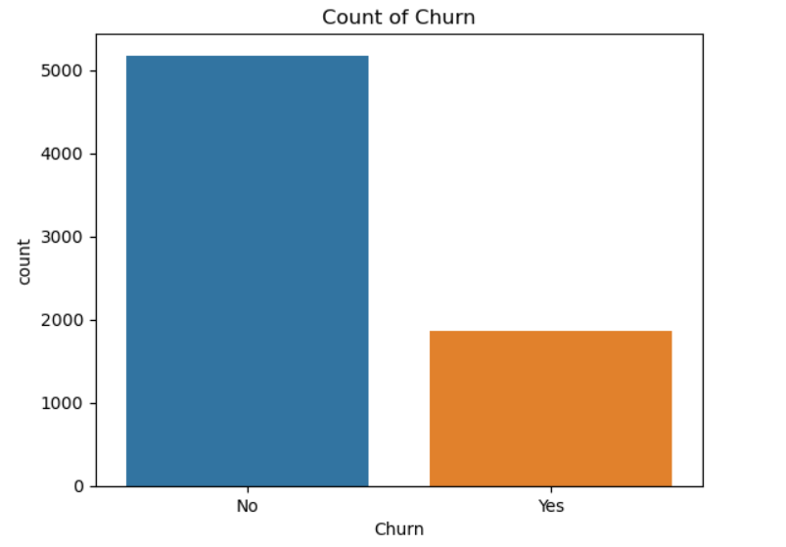
Fig 3 Count of Churn
In the context of a count versus churn analysis, the count typically represents the total number of users, customers, or units within a specific context, such as monthly active users, number of subscriptions. It provides an overall view of the scale and size of the user base or customer engagement. On the other hand, churn refers to the number or percentage of users or customers who discontinue using a service or cancel their subscriptions within a given time frame. This metric is crucial for understanding customer retention and identifying areas where the service may be failing to meet user expectations, leading to loss of engagement or abandonment. Together, these metrics provide insights into the health and sustainability of a business or service, highlighting the balance between growth and retention efforts.
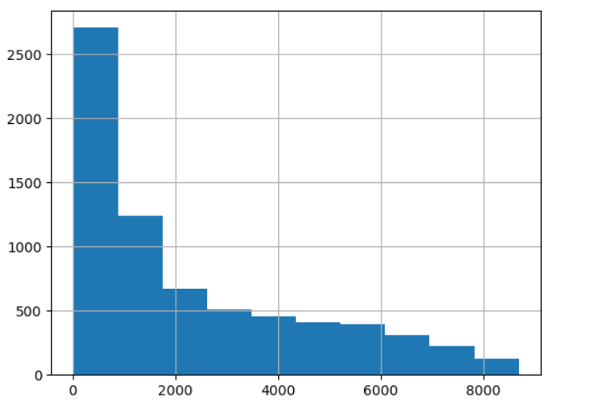

Fig 4 Null Values graph

In this dataset there is no null values, so we don't want to perform Handling missing values. Only perform the Feature Encoding techiniques to convert the categorical feature into numerical feature.

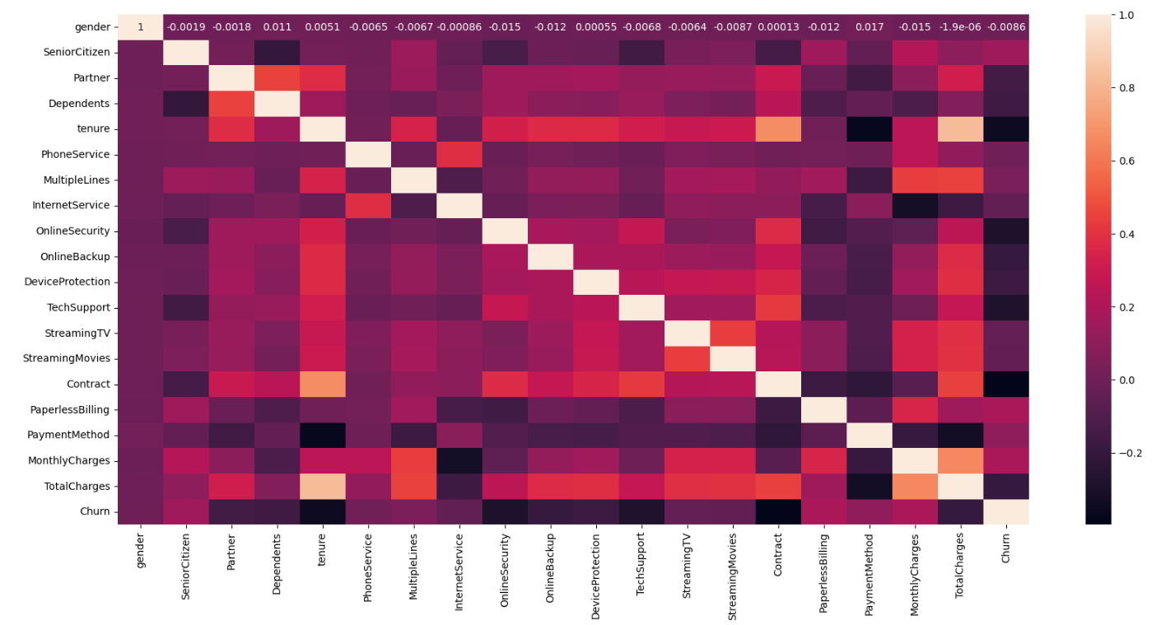

Fig 5 correlation graph

To find and visualize the correlation between independent features (predictors) and the dependent feature (churn outcome) in a customer churn prediction model.

Correlation heatmaps provide a broader view, illustrating the strength and direction of correlations among all features, including the churn outcome. These visualizations help identify key predictors that are strongly related to churn, guiding data-driven decisions for improving customer retention strategies.

Result and Discussion

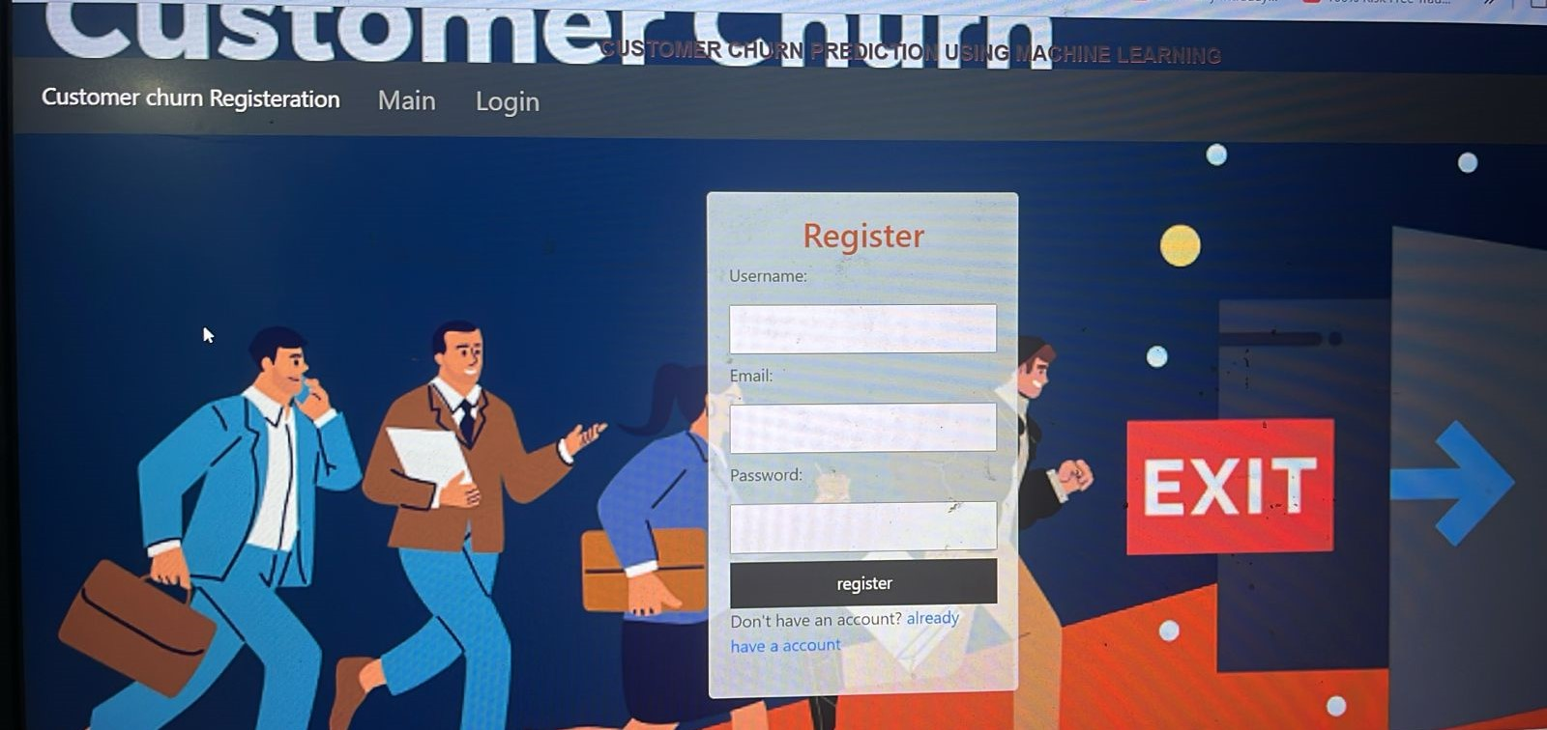

Fig 6 Register Page

A registration page for a customer churn prediction system requires several key components. First, input fields are used to collect essential information like username, email, and password, which form the basis for user authentication. Proper form validation is crucial to ensure the data is accurate and secure—validating email formats and enforcing strong password requirements helps maintain the integrity of user input.

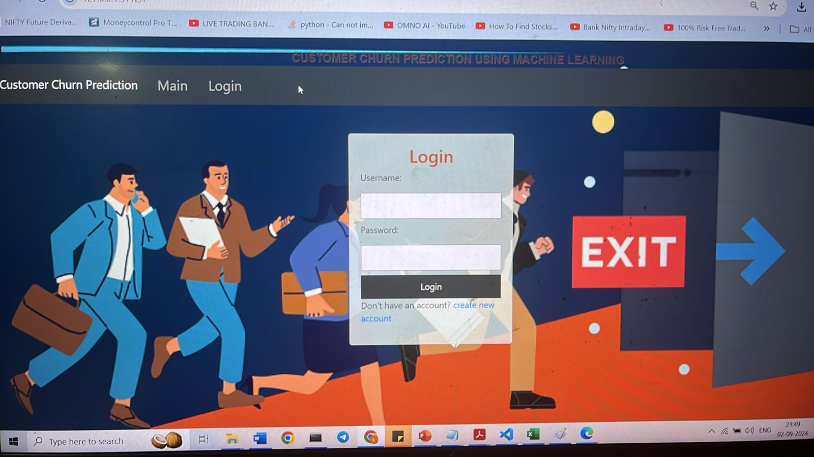

Fig 7 Login Page

A login page for a customer churn prediction system serves as the gateway for users to access the application. It typically includes input fields for the username or email and password, enabling users to authenticate their credentials. Form validation is essential to ensure users enter correct and complete information, such as validating that fields are not left empty and that the email format is correct when applicable.

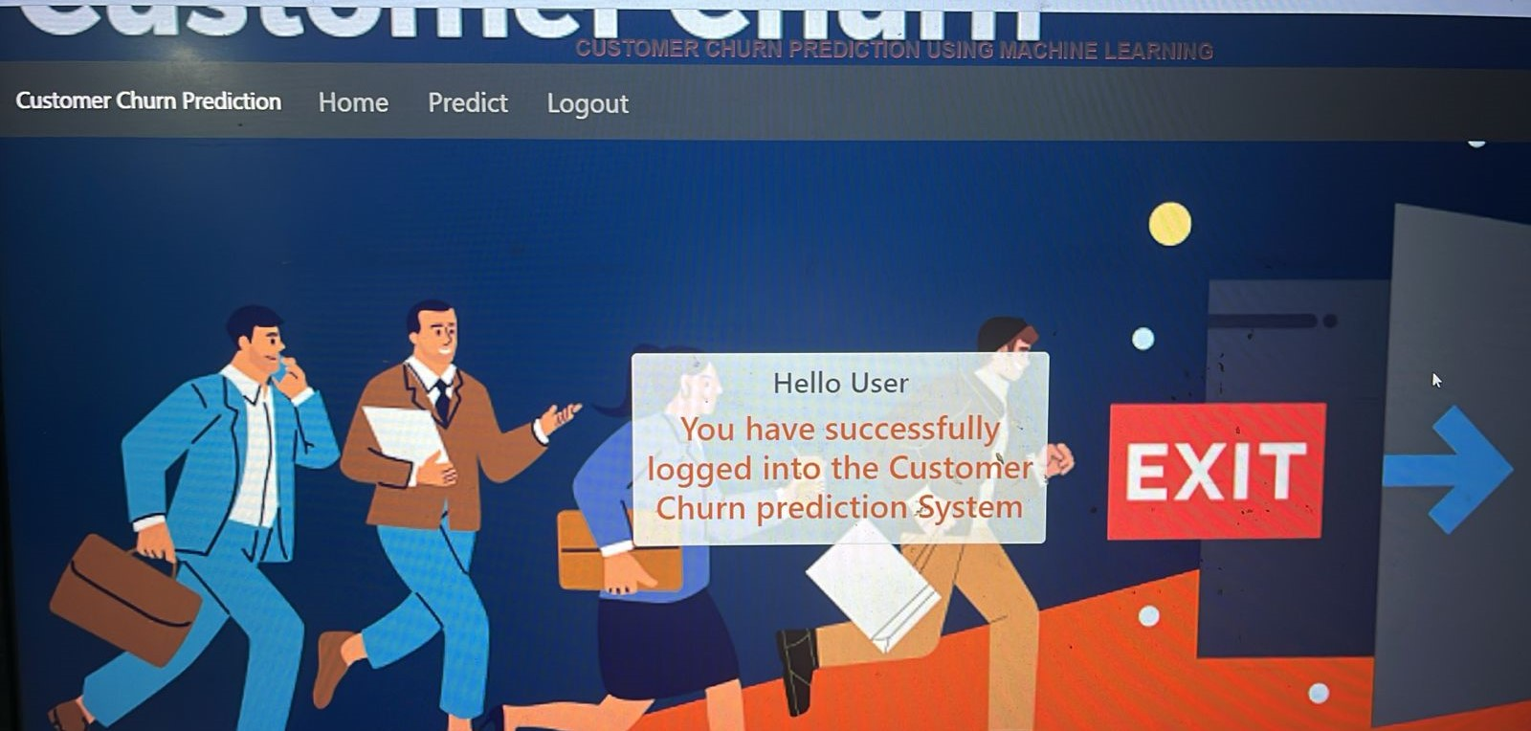

Fig 8 Login successful Page

A successful login page for a customer churn prediction system serves to confirm that the user has been authenticated and is now granted access to the platform. This page typically features a welcoming message, the user's name, or relevant details to personalize the experience. It should provide clear navigation options, such as buttons or links to the main dashboard, prediction tools, and account settings, ensuring users can seamlessly continue their workflow.

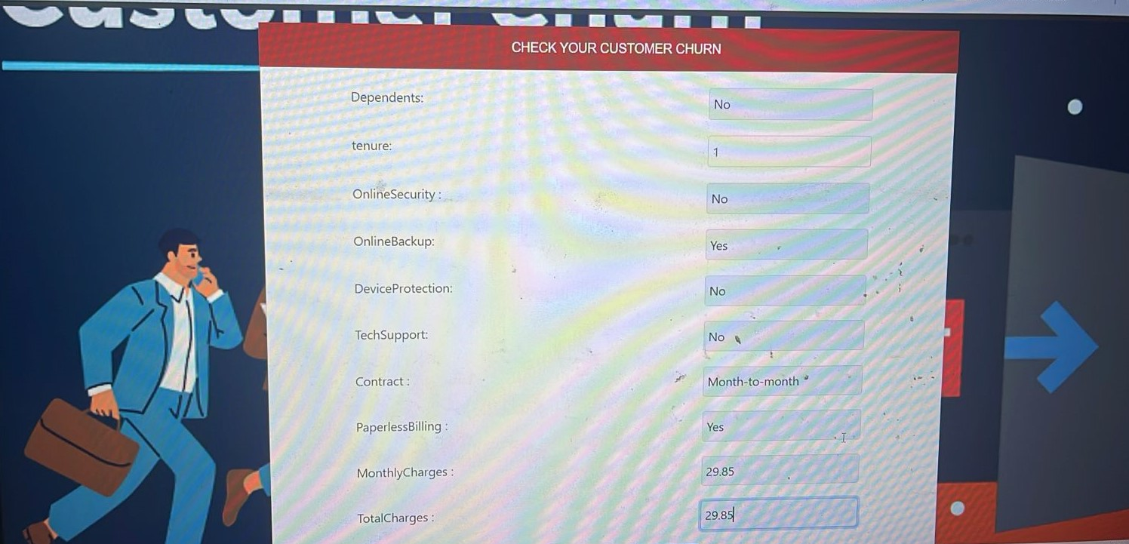

Fig 9 Customer churn checking Page

A customer churn checking page for a customer churn prediction system serves as the interface where users can input customer data to assess the likelihood of churn. This page typically includes input fields to enter customer attributes such as demographic details, transaction history, and usage patterns.

The page integrates with a backend machine learning model trained to predict churn based on these inputs. After the data is submitted, the model analyzes the inputs and returns a prediction indicating the likelihood of the customer leaving. The results are usually displayed in an easy-to-understand format, such as a probability score, risk category (e.g., high, medium, low), or a visual indicator like a color-coded status.

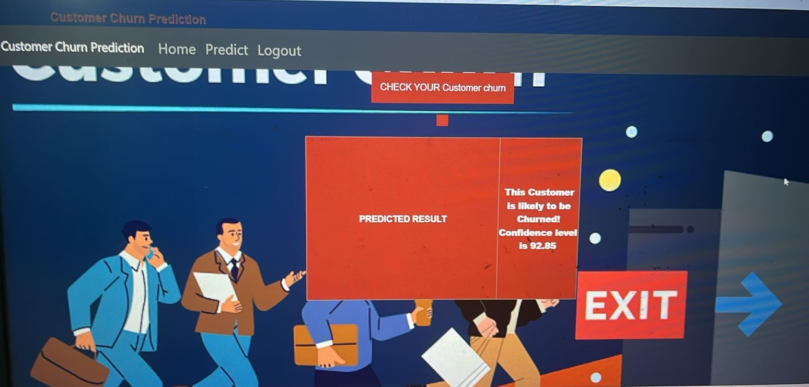

Fig 10 Churn Prediction Page

A Churn Prediction Result Page for a customer churn prediction system provides users with insights into the likelihood of customer churn based on their input data. This page typically displays the prediction results, including whether a customer is likely to churn or not, along with key metrics and factors influencing the prediction.

Key Components of the Churn Prediction Result Page:
- Prediction Outcome: Clearly displays the prediction result, such as "Likely to Churn" or "Not Likely to Churn," giving a quick overview of the customer’s status.
- Probability Score: Shows the probability or confidence level of the prediction, such as “Churn Probability: 85%,” helping users understand the certainty of the result.

Conclusion

The primary goal of this study in the telecom industry is to assist companies in enhancing their profitability. A key revenue stream for telecom firms is predicting customer churn. This research aimed to develop a system capable of accurately forecasting client attrition, with successful prediction models characterized by high AUC (Area Under the Curve) values.

The data was divided into an 80/20 split for training and validation, respectively, to optimize and test the model. Hyperparameter tuning and validation were performed to refine the models. Feature engineering, effective feature transformations, and selection methods were employed to prepare the data for machine learning algorithms.

An imbalance in the data was identified, with only 5% of the entries representing customer churn. This imbalance was addressed through under-sampling techniques or by using tree-based methods that are less affected by data imbalance. Four tree-based algorithms were chosen due to their effectiveness and suitability for this type of prediction: Decision Tree, Random Forest, and Gradient Boosting Machine (GBM) algorithms.

FUTURE SCOPE
The proposed churn prediction system lays a solid groundwork for future enhancements and expansions that can further improve telecom providers' capabilities in managing and reducing customer churn.
The future scope for this system includes several key development areas:

Integration with Real-Time Data: Future versions of the system can incorporate real-time data streams, enabling immediate analysis and prediction of churn. This would allow telecom companies to respond to churn indicators as they arise, leading to more timely and effective interventions.

Incorporation of Advanced Algorithms: As machine learning and artificial intelligence technologies advance, the system can integrate newer and more sophisticated algorithms. Techniques such as deep learning, reinforcement learning, and hybrid models can be explored to further improve prediction accuracy and adapt to complex customer behaviors.

Enhanced Personalization: The system can be developed to offer more personalized retention strategies. By integrating customer segmentation and profiling, telecom providers can tailor their interventions based on individual customer preferences, usage patterns, and service needs.

Expansion to Multi-Channel Data Sources: Beyond traditional customer data, future systems can incorporate data from various channels such as social media, customer service interactions, and IoT devices. This multi-channel approach will provide a richer dataset and deeper insights into customer behavior.

VII.Reference

[1] Gerpott TJ, Rams W, Schindler A. Customer retention, loyalty, and satisfaction in the German mobile cellular telecommunications market. Telecommun Policy. 2001;25:249–69.

[2] Wei CP, Chiu IT. Turning telecommunications call details to churn prediction: a data mining approach Expert Syst Appl. 2002;23(2):103–12.

[3] Qureshii SA, Rehman AS, Qamar AM, Kamal A, Rehman A. Telecommunication subscribers’ churn prediction model using machine learning. In: Eighth international conference on digital information management. 2013. p. 131–6.

[4] Ascarza E, Iyengar R, Schleicher M. The perils of proactive churn prevention using plan recommendations: evidence from a feld experiment. J Market Res. 2016;53(1):46–60.

[5] Bott. Predicting customer churn in telecom industry using multilayer preceptron neural networks:modeling and analysis. Igarss. 2014;11(1):1–5.

[6] Umayaparvathi V, Iyakutti K. A survey on customer churn prediction in telecom industry: datasets, methods and metric. Int Res J Eng Technol. 2016;3(4):1065–70.

[7] Yu W, Jutla DN, Sivakumar SC. A churn-strategy alignment model for managers in mobile telecom. In: Communication networks and services research conference, vol. 3. 2005. p. 48–53.

[8] Burez D, den Poel V. Handling class imbalance in customer churn prediction. Expert Syst Appl.2009;36(3):4626–36.

[9] Zhan J, Guidibande V, Parsa SPK. Identifcation of top-k infuential communities in big networks. J Big Data. 2016;3(1):16. https://doi.org/10.1186/s40537-016-0050-7.
[10] Barthelemy M. Betweenness centrality in large complex networks. Eur Phys J B. 2004;38(2):163–8. https://doi. org/10.1140/epjb/e2004-00111-4.

[11] Elisabetta E, Meyerhenke H, Staudt CL. Approximating betweenness centrality in large evolving networks. CoRR. 2014. arxiv:1409.6241.

[12] Brandusoiu I, Toderean G, Ha B. Methods for churn prediction in the prepaid mobile telecommunications industry. In: International conference on communications. 2016. p. 97–100

[13] Idris A, Khan A, Lee YS. Intelligent churn prediction using machine learning in telecom industry. Hum Centric Comput Inf Sci. 2012;2:6.

[14] Hwang H, Jung T, Suh E. An LTV model and customer segmentation based on customer value: a case study on the wireless telecommunication industry. Expert Syst Appl. 2004;26(2):181–8.

[15] Huang B, Kechadi MT, Buckley B. Customer churn prediction in telecommunications. Expert Syst Appl. 2012;39(1):1414–25.

[16] Coussement K, Van den Poel D. Churn prediction in subscription services: an application of support vector machines while comparing two parameter-selection techniques. Expert Syst Appl. 2008;34(1):313–27.

[17] Tsai CF, Lu YH. Customer churn prediction by hybrid neural networks. Expert Syst Appl. 2009;36(10):12547–53.

[18] Keramati A, Mirmohammadi SM. Improving customer churn prediction with data mining techniques. In: European, Mediterranean & Middle Eastern conference on information systems. 2009.

[19] Lemmens A, Croux C. Bagging and boosting classification trees to predict churn. J Market Res. 2006;43(2):276–86.

[20] Verbeke W, Martens D, Baesens B. Social network analysis for customer churn prediction. Appl Soft Comput. 2014;14:431–46.

[21] Vafeiadis T, Diamantaras KI, Sarigiannidis G, Chatzisavvas KC. A comparison of machine learning techniques for customer churn prediction. Simul Model Pract Theory. 2015;55:1–9

[21] Vafeiadis T, Diamantaras KI, Sarigiannidis G, Chatzisavvas KC. A comparison of machine learning techniques for customer churn prediction. Simul Model Pract Theory. 2015;55:1–9

22] Coussement K, De Bock KW. Customer churn prediction in the online gambling industry: the beneficial effect of ensemble learning. J Bus Res. 2013;66(9):1629–36.

[23] Au WC, Chan KC, Yao XP. A novel evolutionary data mining algorithm with applications to churn prediction.
IEEE Trans Evol Comput. 2003;7(6):532–45.

[24] Idris A, Rizwan M, Khan A. Churn prediction in telecom using random forest and PSO based data balancing in combination with various feature selection strategies. Comput Electr Eng. 2012;38(6):1808–19.

[25] Kaur P, Gosain A, Chhabra JK. Ensemble learning for churn prediction in telecom industry.

